SIT210

Embedded Systems Development

JUSTIN BLAND

218478549

Learning Summary Report

# Self-Assessment Details

The following checklists provide an overview of my self-assessment for this unit.

|  |  |  |  |  |
| --- | --- | --- | --- | --- |
|  | Pass (D) | Credit (C) | Distinction (B) | High Distinction (A) |
| Self-Assessment |  |  | ✓ |  |

Self-Assessment Statement

|  |  |
| --- | --- |
|  | Included |
| Learning Summary Report | ✓ |
| Pass tasks complete | ✓ |

Minimum Pass Checklist

|  |  |
| --- | --- |
|  | Included |
| All Credit Tasks are Complete on OnTrack | ✓ |

Minimum Credit Checklist (in addition to Pass Checklist)

|  |  |
| --- | --- |
|  | Included |
| Distinction tasks (other than Custom Program) are Complete | ✓ |
| Custom program meets Distinction criteria | None |

Minimum Distinction Checklist (in addition to Credit Checklist)

|  |  |
| --- | --- |
|  | Included |
| Something Awesome included | None |
| Custom project meets HD requirements | None |

Minimum High Distinction Checklist (in addition to Distinction Checklist)

# Declaration

I declare that this portfolio is my individual work. I have not copied from any other student’s work or from any other source except where due acknowledgment is made explicitly in the text, nor has any part of this submission been written for me by another person.

Signature: **Justin Bland**

# Portfolio Overview

This portfolio includes work that demonstrates that I have achieve all Unit Learning Outcomes for SIT210 Unit Title to a **Distinction** level.

I believe that, with the exception of the assessment tasks still to be marked and the two tasks due the beginning of next month I have completed all of the Pass, Credit and Distinction Tasks to a level that shows my ability and work to be of a Distinction Level.

# Reflection

## The most important things I learnt:

In this unit the most important thing I think I have learnt is how easy it is for embedded systems to be implemented for almost any use imaginable, especially with the Particle Systems web integration, any device can become an IoT device.

## The things that helped me most were:

The things I feel that helped me the most were the detailed tutorials I found online and the abundance of information in student discussions

## I found the following topics particularly challenging:

What I found challenging was Task 7.1 Project Pitch, I have always had issues with video presentations, I don’t know why it is just something that I have issues with.

## I found the following topics particularly interesting:

I found the Raspberry Pi topics interesting; I have been wanting to play with the Pi for a while but have never had an excuse to buy one.

## I feel I learnt these topics, concepts, and/or tools really well:

I feel I learnt more with the Raspberry Pi topics, primarily because the Particle system isn’t really that much different from the Arduino ecosystem (except for the web events system).

## I still need to work on the following areas:

I feel that I still need to work on more Raspberry Pi topics and have more to work on with web integrated embedded systems

## My progress in this unit was …:

At the time of this screenshot my progress was all Pass, Credit and Distinction tasks complete except for this task and both Week 11 tasks, additionally the progress burndown shows almost all of my tasks have been submitted well before they were due.

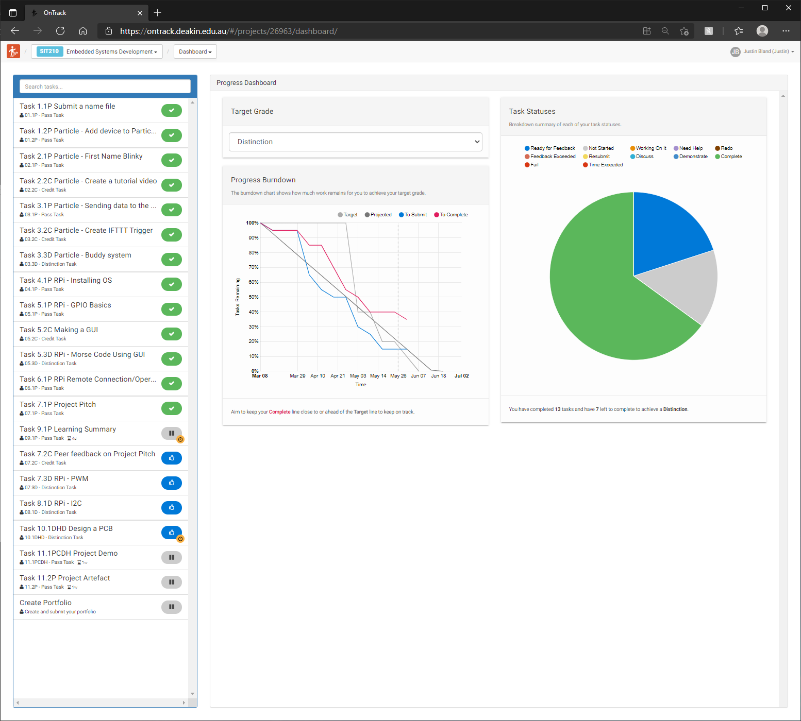

## This unit will help me in the future:

What I have learnt in this unit might not necessarily be useful in the rest of my degree, however it should prove useful should I ever have the need to create an embedded system, and the Raspberry Pi tasks will definitely help with my current work, as having one and some knowledge of them I have already started implementing them as 3CX Phone System for small businesses

## If I did this unit again, I would do the following things differently:

If I had to do this unit again the only thing that comes to mind would be to purchase hardware earlier, I ended up having to purchase my Particle Argon, Raspberry Pi and sensors from Mouser and have them shipped from Hong Kong as there was no sock in the country.